**Final Project Report**

**TaskBoss**

**(Get a Freelancer)**



**Project Supervisor**

Amna Bibi

**Submitted By**

S2102EB3F9

Aneela Kausar MC190400182

Noreen Akhter MC180405463

**Software Projects & Research Section,**

**Department of Computer Sciences,**

**Virtual University of Pakistan**

|  |
| --- |
|  |



**CERTIFICATE**

This is to certify that Aneela Kausar (MC190400182), Noreen Akhter (MC180405463) have worked on and completed their Software Project at Software & Research Projects Section, Department of Computer Sciences, Virtual University of Pakistan in partial fulfillment of the requirement for the degree of BS in Computer Sciences under my guidance and supervision.

In our opinion, it is satisfactory and up to the mark and therefore fulfills the requirements of BS in Computer Sciences.

**Supervisor / Internal Examiner**

Amna Bibi

Supervisor,

Software Projects & Research Section,

Department of Computer Sciences

Virtual University of Pakistan

___________________

(Signature)

**External Examiner/Subject Specialist**

<<External Supervisor Name>>

___________________

(Signature)

**Accepted By:**

**____________**

(For office use)

**EXORDIUM**

In the name of Allah, the Compassionate, the Merciful.

Praise be to Allah, Lord of Creation,

The Compassionate, the Merciful,

King of Judgment-day!

You alone we worship, and to You alone we pray for help,

Guide us to the straight path

The path of those who You have favored,

Not of those who have incurred Your wrath,

Nor of those who have gone astray.

**DEDICATION**

To our parents

&

To our friends

who encourage and support us**ACKNOWLEDGEMENT**

This is to acknowledge all those without whom this project would not have been reality. Firstly, I would wish to thank our Computer Science Supervisor Ms. Amna Bibi who gave her immense support, dedicated her time towards it and made us understand how to make this project. Without her guidance, the project would not have been complete.

The matter contained in it has been widely used in current era. The source-code of the project is written by learn and develop way. The technology used in this developed is currently used in software industry.

**PREFACE**

This project report is organized in three chapters for ease of usage. Every chapter defines a detailed discussion of this project.

Chapter 1 explains the software requirements specifications of this project. The scope of this project, the functional and non-functional requirements, the use case scenarios, discussion of different methodologies with adopted methodology used in this project and work-plan in form of Gantt-chart, which includes the time division to complete each task are the part of this chapter.

Chapter 2 includes all design phases of the project. Entity Relationship diagrams, Architecture design diagram and Class diagrams are part of this phase. The chapter also includes the interface design of the project. Test cases of the project also written in this chapter.

Chapter 3 is about development plan, technologies and implementation. In this phased the project is developed and converted into its final shape.

**TABLE OF CONTENTS**

|  |
| --- |
|  |

1 Introduction 10

2 Purpose 10

3 Scope 10

4 Functional and non-Functional Requirements: 11

4.1 Functional Requirements: 11

4.1.1 Homepage: 11

4.1.2 Sign Up: 11

4.1.3 Sign In: 11

4.1.4 Profile Page: 12

4.1.5 Find Freelancer: 12

4.1.6 Find Work: 13

4.1.7 Notification: 14

4.1.8 Payment: 14

4.1.9 Rating: 14

4.2 Non-Functional Requirements: 15

4.2.1 Performance: 15

4.2.2 Usability: 15

4.2.3 Reliability: 15

4.2.4 Portability: 15

5 Use Cases and Usage Scenarios 16

5.1 Use Case Diagram: 16

5.2 Usage Scenarios: 17

5.2.1 Homepage: 17

5.2.2 Sign Up: 18

5.2.3 Sign In: 19

5.2.4 Profile: 20

5.2.5 Find Freelancer: 21

5.2.6 Post a Job: 22

5.2.7 Find a Project: 23

5.2.8 Find Work: 24

5.2.9 Find Job: 25

5.2.10 Apply on Project: 26

5.2.11 Display Project: 27

5.2.12 Approve Project: 28

5.2.13 Notification: 29

5.2.14 Payment: 30

5.2.15 Rating: 31

6 Development Methodology: 32

6.1 Adopted Methodology: VU Process Model: 32

6.2 Reasons to choose VU Process Model: 32

6.3 Work Plan: 33

6.4 Project Schedule 34

1 Introduction 36

2 Scope 36

3 Architecture Design Diagram 36

4 Sequence Diagrams 37

4.1 Sign-Up: 37

4.2 Sign-In: 38

4.3 Find Work: 39

5 Class Diagram 40

6 Database Diagram 41

7 Graphical User Interfaces 42

7.1 Menu bar 42

7.2 Home Screen 43

7.3 SignUp 44

7.4 SignIn 45

7.5 Post Job / Dispay Proect 46

7.6 Find Project / Find Job 47

1 Architecture Diagram 49

CHAPTER 1

Gathering & Analyzing Info

# Introduction

This chapter contains the fundamental information of project. The purpose of this chapter is to analyze the market and gathered the functional and non-functional requirements of the project. The results help to draw use case diagram, use case scenarios. Methodology is defined to follow the project construction then draw a work plane to follow a managed work. On the basis of results the structure of the project is designed.

# Purpose

In current era, businesses are mostly shifted online. Where companies need online websites, stores etc. To fulfill their need they hire people locally or online via freelancing websites. Companies prefer online hiring, because they get high quality work in low budget and within time.

The nature of our purposed website is to make a bridge between the freelancer and client. Freelancing refers to working as independent company. A freelancer is a self-employed person, who hired by other contractors or companies on task-based or time-based work for short time.

# Scope

“TaskBoss” is a freelance web application that features find a freelancer or to get work online. The user(s) will be able to sign up, sign in, post a project, receive notifications from freelancers, view the profile of freelancers, hire a freelancer, find work, apply on job(s) and receive amount and will get charge for a successful project completion.

# Functional and non-Functional Requirements:

## Functional Requirements:

### Homepage:

This page will have task bar containing 4 main tabs and 2 additional tabs.

* Find Freelancer
* Find Work
* Sign In
* Sign Up
* Profile
* Notification

Body of page will used to display services in following domains, offered by website. Where list of sub-domains of each corresponding domain will be available by clicking on it.

* Development and IT
* Writing and Transaction
* Accounts and Finance

### Sign Up:

Sign Up page will allow user(s) to register their selves on “Get A Freelancer” platform using required fields.

* Email id,
* Password,
* Domain
* Sub domain

### Sign In:

This page will allow user to login into the freelance platform using credentials (email id and password).

### Profile Page:

Profile page will contain all details of registered user. Page will show 2 fields need to filled by freelancer.

* Skills
* Level of expertise in relevant skill

### Find Freelancer:

“Find Freelancer” tab will allow client to search freelancer by 2 ways:

* Post a Job
* Find a Project

#### Post a Job:

Page will enable only for registered users. If user will not be logged in, it will redirect to Signup/Login page.

Page will allow client to post a new job. He/she will must need to fill the following fields to place the task.

* Domain
* Sub-domain
* Description of the project
* Skills required
* Expert level
* Budget
* Time slot

#### Find a Project:

Tab will enable only for registered clients. If client will not be logged in, it will redirect to Signup/Login page.

Page will display all 3 major domains. List of successfully completed projects with their developer or freelancer name and other details will be displayed under the relevant domain.

#### Approve Project:

Page will only enable for registered clients.

Page will show list of applications against the Job placement.

Client will allow to view the following information of freelancer by click on it

* Profile
* Rank
* Rate
* Time slot

Client will allow to approve any freelancer, which suits with the job.

### Find Work:

“Find Work” tab will show drop down list on click, having following page links.

* Find Job
* Display Project

#### Find Job:

Tab will enable only for registered users. If user will not be logged in, it will redirect to Signup/Login page.

Page will display all domains with sub-domains, and will allow user to click on any domain with its sub domain. List of all available relevant jobs against domain will be displayed on page. Page will allow user to click on any job, and will display its description. User will be allowed to apply on any job.

##### Apply on Project Page:

Page will only be enabled for registered users. Multiple freelancers can apply on single job. Page will have following options to be filled by the freelancer:

* Rate per hour
* Number of days
* Submit Proposal button. (to send his/her rates to the client)

#### Display Project:

Page will only enable for registered freelancers.

Display Page will allow user to select domain with corresponding sub-domain. Unser this category page will allow freelancer to add his/her personal complete project with description, rates and time spend to complete it.

Page will also have a publish project on profile option. By which freelancer’s project will included in completed projects catalogue.

### Notification:

Notification will be received by the client, if he/she approve the freelancer’s proposal.

### Payment:

Payment will be released to freelancer’s account and 5% of the total amount will be deducted from both client and freelancer credits, by the “TaskBoss” web application, when job will be completed.

### Rating:

Rating will be enabled for both client and freelancer, when job will be completed. Client will be able to check rating of freelancer, which will help him/her to assign order to freelancer.

## Non-Functional Requirements:

### Performance:

Load time of web application will be very lower, even on poor network connections.

### Usability:

Web Application will have a simple user-friendly interface, e.g. zooming allow any user to set text as per need.

### Reliability:

Web Application will respect its user’s privacy and rights, e.g. keep the amount of job after two days of job end. Both client and freelancer can apply to administration for project relate issues.

### Portability:

Web application will open in different environments.

# Use Cases and Usage Scenarios

## Use Case Diagram:

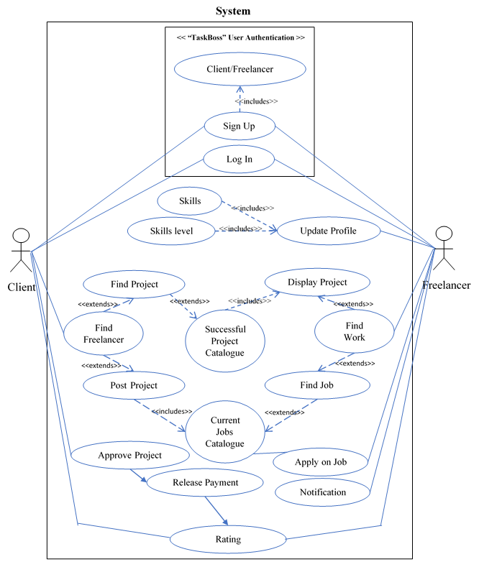

Fig1.1: Use Case Diagram of “TaskBoss”

## Usage Scenarios:

### Homepage:

|  |  |  |
| --- | --- | --- |
| **Use Case Title:** | Homepage | |
| **Abbreviated Title:** | Default Page | |
| **Use Case Id:** | 1 | |
| **Requirement Id:** | - | |
| **Description:**   * Use case “Homepage” is for loading the web application in browser. | | |
| **Pre-Condition:**   * Internet is enabled on device. * Browser is opened. | | |
| **Task Sequence:**   * URL of “TaskBoss” is entered in the address bar of browser. * Press enter key or Ok button. * Web app. is loading. | | **Exception:**   * If there is typo in URL, error 404 will displayed in browser. |
| **Post- Condition:**   * Homepage loaded successfully. * Home page of web app. is loaded in browser window. * 4 main tabs and 2 additional tabs are displayed in task bar of web-app and clickable for user. | | |
| **Alternative Path(s):**   * Presses refresh button to reload the website. | | |
| **Unresolved Issues:**   * NA | | |
| **Authority:**   * User, Web-browser | | |
| **Modification History:** 1.0  **Author:** S2102EB3F9 (MC190400182, MC180405463) | | |

### Sign Up:

|  |  |  |
| --- | --- | --- |
| **Use Case Title:** | Sign Up | |
| **Abbreviated Title:** | Register | |
| **Use Case Id:** | 2 | |
| **Requirement Id:** | 1 | |
| **Description:**   * Use case “Signup” is about registration of user on “TaskBoss” freelance web forum. | | |
| **Pre-Condition:**   * “TaskBoss” is loaded on bower and all tabs all enabled and clickable for user. | | |
| **Task Sequence:**   * User clicks on “Signup” tab. * “TaskBoss” displays Signup page. * User fills all the required fields. * User clicks on Submit button. | | **Exception:**   * If any input field not filled by user, page make it red and disabled Submit button |
| **Post- Condition:**   * User filed all required fields and Submit button pressed successfully. * User data sent to server successfully. | | |
| **Alternative Path(s):**   * Press “Escape” button or click on “X” to close the page, if user don’t want to register. | | |
| **Unresolved Issues:**   * NA | | |
| **Authority:**   * User, Web-browser, Server | | |
| **Modification History:** 1.0  **Author:** S2102EB3F9 (MC190400182, MC180405463) | | |

### Sign In:

|  |  |  |
| --- | --- | --- |
| **Use Case Title:** | Sign In | |
| **Abbreviated Title:** | Login | |
| **Use Case Id:** | 3 | |
| **Requirement Id:** | 1, 2 | |
| **Description:**   * Use case “Sign in” is about to enter in the “TaskBoss” freelance web forum. | | |
| **Pre-Condition:**   * “TaskBoss” is loaded on bower and all tabs all enabled and clickable for user. | | |
| **Task Sequence:**   * User clicks on “Sign in” tab. * “TaskBoss” displays Sign in page. * User fills registered email with correct password. * User clicks on Sign In button. | | **Exception:**   * If user entered wrong email id or password, an error message will be displayed. “Please enter correct Email id or password”. |
| **Post- Condition:**   * Browser sent request of user’s credentials to server successfully. * Server match data with saved data. If found exactly matched, then return ok signal, and sign in user into forum. | | |
| **Alternative Path(s):**   * Press “Escape” button or click on “X” to close the page, if user don’t want to register. | | |
| **Unresolved Issues:**   * Server denied unregistered user to enter into forum forcefully. | | |
| **Authority:**   * User, Web-browser, Server | | |
| **Modification History:** 1.0  **Author:** S2102EB3F9 (MC190400182, MC180405463) | | |

### Profile:

|  |  |  |
| --- | --- | --- |
| **Use Case Title:** | Profile | |
| **Abbreviated Title:** | NA | |
| **Use Case Id:** | 4 | |
| **Requirement Id:** | 1, 3 | |
| **Description:**   * Use case “Profile” is about to display saved details of users and ask freelancer to fill skills and its level of expertise in it. | | |
| **Pre-Condition:**   * Registered user of “TaskBoss” wen app. is logged in successfully. | | |
| **Task Sequence:**   * User clicks on “Profile” tab. * “TaskBoss” displays Profile page. * New user fills his/her skill with the level of expertise in each. * Save button is pressed to save changes. * Existing User can see saved profile. | | **Exception:**   * If new freelancer tries to apply on any job with completing his/her profile, web app. show caution to move back on profile page and complete it first. |
| **Post- Condition:**   * Browser sent request of new user’s changes in profile to server successfully. * Server saved the data. * Browser loaded saved information. | | |
| **Alternative Path(s):**   * NA | | |
| **Unresolved Issues:**   * NA | | |
| **Authority:**   * User, Web-browser, Server | | |
| **Modification History:** 1.0  **Author:** S2102EB3F9 (MC190400182, MC180405463) | | |

### Find Freelancer:

|  |  |  |
| --- | --- | --- |
| **Use Case Title:** | Find Freelancer | |
| **Abbreviated Title:** | NA | |
| **Use Case Id:** | 5 | |
| **Requirement Id:** | 1, 3 | |
| **Description:**   * Use case “Find Freelancer” is a place where client can search the skilled freelancer with matched expertise for his/her work done. | | |
| **Pre-Condition:**   * Registered Client of “TaskBoss” is logged in successfully. | | |
| **Task Sequence:**   * User clicks on “Find Freelancer” tab a DDL will appear with 2 clickable options.   + Post a Job   + Find a Project | | **Exception:** |
| **Post- Condition:**   * Client clicked on any one from 2 options. The corresponding page will be opened in browser. | | |
| **Alternative Path(s):**   * NA | | |
| **Unresolved Issues:**   * NA | | |
| **Authority:**   * User, Web-browser | | |
| **Modification History:** 1.0  **Author:** S2102EB3F9 (MC190400182, MC180405463) | | |

### Post a Job:

|  |  |  |
| --- | --- | --- |
| **Use Case Title:** | Post a Job | |
| **Abbreviated Title:** | NA | |
| **Use Case Id:** | 6 | |
| **Requirement Id:** | 1, 3, 5 | |
| **Description:**   * Use case “Post a Job” is about to place a work by client on the freelance forum. | | |
| **Pre-Condition:**   * Client clicked on “Post a Job” option from DDL of “Find Freelancer”. * “Post a Job” page loaded in browser. | | |
| **Task Sequence:**   * Client selects domain with sub-domain matched with his/her work. * Client fills Description of Job, with required fields.  |  |  | | --- | --- | | * + Skills required | * + Budget | | * + Expert level | * + Time slot |  * Client clicks on saved button. | | **Exception:** |
| **Post- Condition:**   * Client filled all required fields to showcase the work and saved it. * Browser sent it to server to save in database. * Server added new job in the Active Projects list against corresponding domain. | | |
| **Alternative Path(s):**   * Client can search freelancer by successfully completed projects without posting job in showcase. | | |
| **Unresolved Issues:**   * NA | | |
| **Authority:**   * Client, Web-browser, Server | | |
| **Modification History:** 1.0  **Author:** S2102EB3F9 (MC190400182, MC180405463) | | |

### Find a Project:

|  |  |  |
| --- | --- | --- |
| **Use Case Title:** | Find a Project | |
| **Abbreviated Title:** | NA | |
| **Use Case Id:** | 7 | |
| **Requirement Id:** | 1, 3, 5 | |
| **Description:**   * Use case “Find a Project” is about to search a freelancer by his/her displayed projects. | | |
| **Pre-Condition:**   * Client clicked on “Find a Project” option from DDL of “Find Freelancer”. * “Find a Project” page loaded in browser. | | |
| **Task Sequence:**   * “Find a Project” page displayed 3 main domains of web app.   + Development and IT   + Writing and Transaction   + Accounts and Finance * Client selects domain with sub-domain matched with his/her work. * List of successfully completed projects with their freelancer name and other details will be displayed under the relevant domain. | | **Exception:** |
| **Post- Condition:**   * Client found the projects matched with requirements. | | |
| **Alternative Path(s):**   * Client can search freelancer by posting project in showcase. | | |
| **Unresolved Issues:**   * NA | | |
| **Authority:**   * Web-browser, Server | | |
| **Modification History:** 1.0  **Author:** S2102EB3F9 (MC190400182, MC180405463) | | |

### Find Work:

|  |  |  |
| --- | --- | --- |
| **Use Case Title:** | Find Work | |
| **Abbreviated Title:** | NA | |
| **Use Case Id:** | 8 | |
| **Requirement Id:** | 1, 3, 4 | |
| **Description:**   * Use case “Find Work” is a place where freelancer can search the job matched with his/her expertise. | | |
| **Pre-Condition:**   * Freelancer has completed his/her profile successfully. | | |
| **Task Sequence:**   * Freelancer clicks on “Find Work” tab a DDL will appear with 2 clickable options.   + Find Job   + Display Project | | **Exception:** |
| **Post- Condition:**   * Freelancer clicked on any one from 2 options. The corresponding page will be opened in browser. | | |
| **Alternative Path(s):**   * NA | | |
| **Unresolved Issues:**   * NA | | |
| **Authority:**   * User, Web-browser | | |
| **Modification History:** 1.0  **Author:** S2102EB3F9 (MC190400182, MC180405463) | | |

### Find Job:

|  |  |  |
| --- | --- | --- |
| **Use Case Title:** | Find Job | |
| **Abbreviated Title:** | NA | |
| **Use Case Id:** | 9 | |
| **Requirement Id:** | 1, 3, 4, 8 | |
| **Description:**   * Use case “Find Job” is about to find a work by freelancer on the freelance forum. | | |
| **Pre-Condition:**   * Client clicked on “Find Job” option from DDL of “Find Work”. * “Find Job” page loaded in browser with all major domain and sub-domains. | | |
| **Task Sequence:**   * Freelancer selects domain with sub-domain matched with skills. * List of Jobs against corresponding sub-domain will be displayed on page and clickable for freelancer. * Client fills Description of Job, with required field * User clicks on any Job; its complete description will be opened in new page. * If Job matched with skills, he/she can apply on it. | | **Exception:** |
| **Post- Condition:**   * Server displays all Active Projects list against corresponding domain. * “Apply” button is enables on Job description page for freelancer. | | |
| **Alternative Path(s):**   * Client can search Job by displaying his/her projects on profile. | | |
| **Unresolved Issues:**   * NA | | |
| **Authority:**   * User, Web-browser, Server | | |
| **Modification History:** 1.0  **Author:** S2102EB3F9 (MC190400182, MC180405463) | | |

### Apply on Project:

|  |  |  |
| --- | --- | --- |
| **Use Case Title:** | Apply on Project | |
| **Abbreviated Title:** | NA | |
| **Use Case Id:** | 10 | |
| **Requirement Id:** | 1, 3, 4, 8, 9 | |
| **Description:**   * Use case “Apply on Project” is like showing interest in a work by freelancer at client’s desired job. | | |
| **Pre-Condition:**   * Freelancer clicked on “Apply on Project” button on the description page of selected projects. | | |
| **Task Sequence:**   * “Apply on Project” page opened. * Freelancer filled following options:   + Rate per hour   + Number of days   + Submit Proposal button. (to send his/her rates to the client) * Freelancer press/clicks on Submit button. | | **Exception:** |
| **Post- Condition:**   * Server sent notification to the client about freelancer’s interest. | | |
| **Alternative Path(s):**   * NA | | |
| **Unresolved Issues:**   * NA | | |
| **Authority:**   * Freelancer, Web-browser, Server | | |
| **Modification History:** 1.0  **Author:** S2102EB3F9 (MC190400182, MC180405463) | | |

### Display Project:

|  |  |  |
| --- | --- | --- |
| **Use Case Title:** | Display Project | |
| **Abbreviated Title:** | NA | |
| **Use Case Id:** | 11 | |
| **Requirement Id:** | 1, 3, 4, 8 | |
| **Description:**   * Use case “Display Project” describes, how freelancer can add his/her personal complete project(s) in his/her profile. | | |
| **Pre-Condition:**   * Freelancer clicked on “Display Project” option from “Find Work” DDL. | | |
| **Task Sequence:**   * “Display Project” page opened. * Freelancer is select domain with sub-domain. * Freelancer filles following options:   + Project description   + Time spent on project.   + Rate for clients * Freelancer press/clicks on Submit button. | | **Exception:** |
| **Post- Condition:**   * Projects details sent to server by browser. * Server saved in successful projects catalogue. | | |
| **Alternative Path(s):**   * NA | | |
| **Unresolved Issues:**   * NA | | |
| **Authority:**   * Freelancer, Web-browser, Server | | |
| **Modification History:** 1.0  **Author:** S2102EB3F9 (MC190400182, MC180405463) | | |

### Approve Project:

|  |  |  |
| --- | --- | --- |
| **Use Case Title:** | Notification | |
| **Abbreviated Title:** | NA | |
| **Use Case Id:** | 12 | |
| **Requirement Id:** | 1, 3, 5, 6, 7 | |
| **Description:**   * Use case “Approve Project” is about to assign a project to a freelancer by client. | | |
| **Pre-Condition:**   * Client has checked the freelancer’s profile. * Client clicked on “Approve Project” option on project description button. | | |
| **Task Sequence:**   * Client press the “Approve Project” button. * Budget placed by client passed to server. | | **Exception:** |
| **Post- Condition:**   * Server reserved the client’s budget till the project end date including 2 extra days. * Server save information of deal in its database. | | |
| **Alternative Path(s):**   * NA | | |
| **Unresolved Issues:**   * NA | | |
| **Authority:**   * Freelancer, Client, Web-browser, Server | | |
| **Modification History:** 1.0  **Author:** S2102EB3F9 (MC190400182, MC180405463) | | |

### Notification:

|  |  |  |
| --- | --- | --- |
| **Use Case Title:** | Notification | |
| **Abbreviated Title:** | NA | |
| **Use Case Id:** | 13 | |
| **Requirement Id:** | 1, 3, 9, 10, 11, 12 | |
| **Description:**   * Use case “Notification” is about to show assigned project by client to the freelancer. | | |
| **Pre-Condition:**   * Client has assigned the project to the client by clicking “Approve Project” button. * Server keeps the budget placed by client for project. | | |
| **Task Sequence:**   * Freelancer receives approval notification of project by client(s). * Freelancer can open notification(s) by clicking on it. | | **Exception:** |
| **Post- Condition:**   * Server reserved the client’s budget till the project end date including 2 extra days. | | |
| **Alternative Path(s):**   * NA | | |
| **Unresolved Issues:**   * NA | | |
| **Authority:**   * Freelancer, Client, Web-browser, Server | | |
| **Modification History:** 1.0  **Author:** S2102EB3F9 (MC190400182, MC180405463) | | |

### Payment:

|  |  |  |
| --- | --- | --- |
| **Use Case Title:** | Payment | |
| **Abbreviated Title:** | NA | |
| **Use Case Id:** | 14 | |
| **Requirement Id:** | 1, 3, 12 | |
| **Description:**   * Use case “Payment” is about to the earning by both parties and to the “TaskBoss” services payment. | | |
| **Pre-Condition:**   * The project assigned by client is completed by freelancer. * Both parties have no objection on work. | | |
| **Task Sequence:**   * Budget is transferred to client’s account after deduction of 5% web app. fees from both parties. | | **Exception:** |
| **Post- Condition:**   * Server added the project in successful projects catalogue. * Rating is enabled for both parties. | | |
| **Alternative Path(s):**   * NA | | |
| **Unresolved Issues:**   * NA | | |
| **Authority:**   * Freelancer, Client, Web-browser, Server | | |
| **Modification History:** 1.0  **Author:** S2102EB3F9 (MC190400182, MC180405463) | | |

### Rating:

|  |  |  |
| --- | --- | --- |
| **Use Case Title:** | Notification | |
| **Abbreviated Title:** | NA | |
| **Use Case Id:** | 13 | |
| **Requirement Id:** | 1, 3, 15Rating | |
| **Description:**   * Use case “Rating” is about to views of freelancer and client, how the work done. | | |
| **Pre-Condition:**   * Project assigned by client is completed by freelancer. * Payment is cleared. | | |
| **Task Sequence:**   * Rating page is opened. * Client can rate freelancer about his/her proficiency, dedication and sincerity with assigned work. * Freelancer can rate the professional attitude about assigning task, and about giving details. | | **Exception:** |
| **Post- Condition:**   * Server add rating into freelancer’s profile. | | |
| **Alternative Path(s):**   * NA | | |
| **Unresolved Issues:**   * NA | | |
| **Authority:**   * Freelancer, Client, Web-browser, Server | | |
| **Modification History:** 1.0  **Author:** S2102EB3F9 (MC190400182, MC180405463) | | |

# Development Methodology:

## Adopted Methodology: VU Process Model:

VU Process Model or Hybrid Model is the combination of waterfall and spiral models. So VU Process Model is combined linear-iterative process. Due to its hybrid nature, it reduces the cones of both models. This model modified traditional waterfall model by including risk ability to captures the risk and reduce them. Spiral model has risk ability quality. By adding iterations in every stage of waterfall model, reduces risks.

Fig: VU Process Model

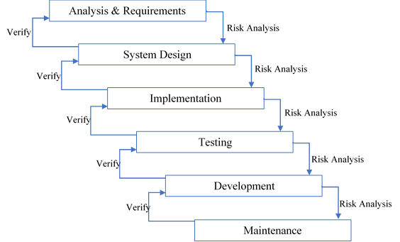

## Reasons to choose VU Process Model:

VU Final Year project is divided into multiple phases. Where each phase starts after other. Which is true nature of waterfall model. But waterfall model has some cones. Which are if there is some problem in previous completed stage. The project can't move forward. To remove this hurdle, VU Process model adopts the Spiral Model. Addition of iterations in Waterfall Model removed this barrier.

## Work Plan:

## Project Schedule

|  |  |  |  |  |
| --- | --- | --- | --- | --- |
| **No** | **Phases** | **Deliverables** | **Description** | **Submission Date** |
| 1 | Data Gathering and Analysis Requirements and Planning Phase | SRS Document | Describe project scope, functional and non-functional requirements, use-case diagrams, methodology and usage scenarios and work plan of project. | 15-06-2021 |
| 2 | Analysis and Design Phase | Design Document | Contains ER diagrams, Architecture design diagram and Class diagrams, interface design of the project. Test cases of the project also written in this chapter. | 15-07-2021 |
| 3 | Test Phase | Test Phase | Viva test is part of this phase | 02-08-2021 |
| 4 | Final Deliverable | Final Deliverable | This phase contains Project Code, final document report and presentation of project. | 25-10-2021 |

CHAPTER 2

Designing the Project

# Introduction

This chapter describes the design phase of freelance website project. explains the features and operations of development in briefly. This is very critical phase in the software development lifecycle. The overall structure of project based on this chapter. Basically, this it describes the project development logically.

# Scope

Design Document of “TaskBoss” website is discussed here. TaskBoss will be a freelance website. Where freelancers can find work as per their desired time slots and budget, and clients can get work done, in their desired budget and time efficiently.

# Architecture Design Diagram

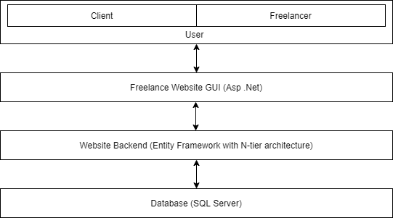

# Sequence Diagrams

## Sign-Up:

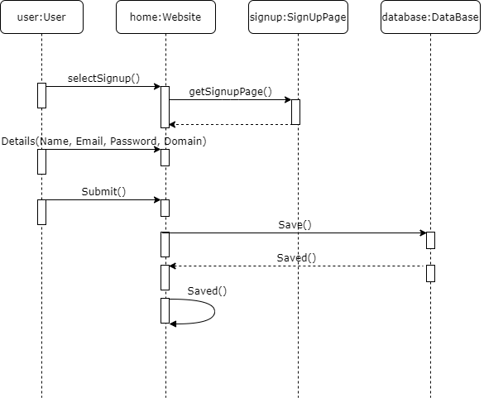

## Sign-In:

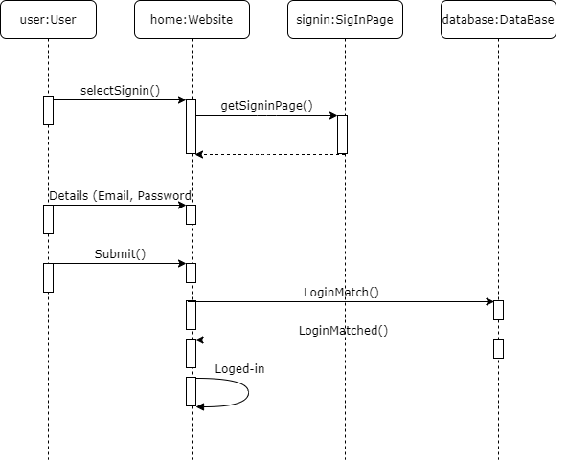

## Find Work:

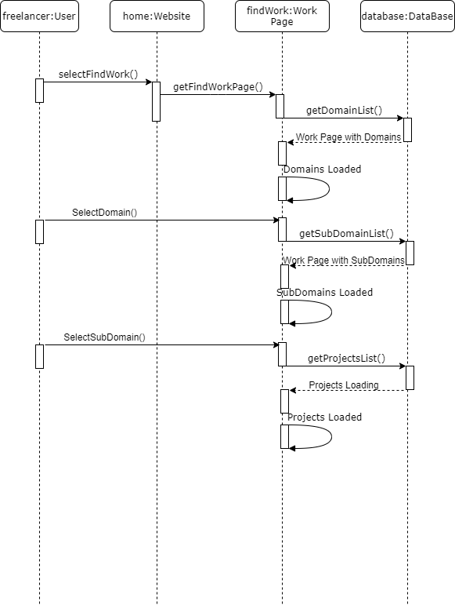

# Class Diagram

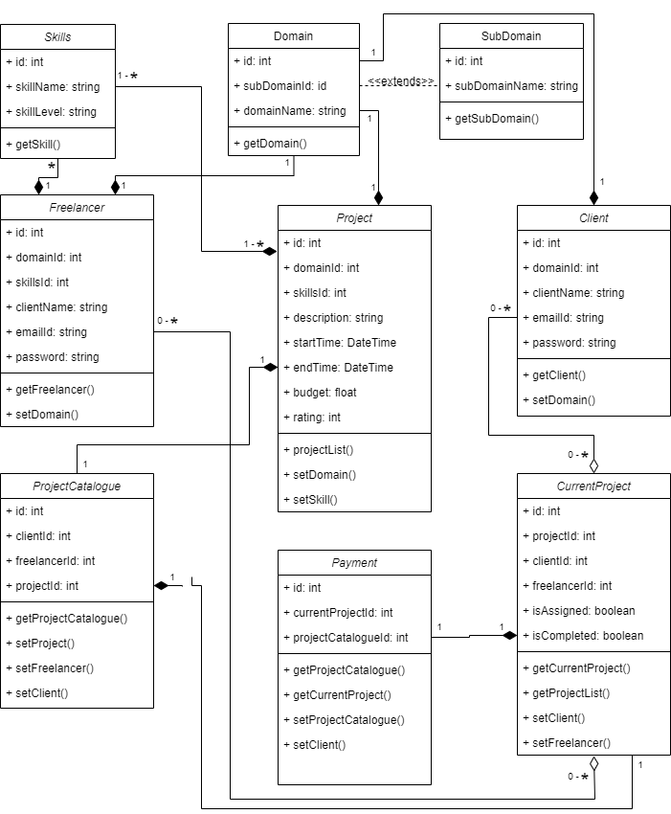

# Database Diagram

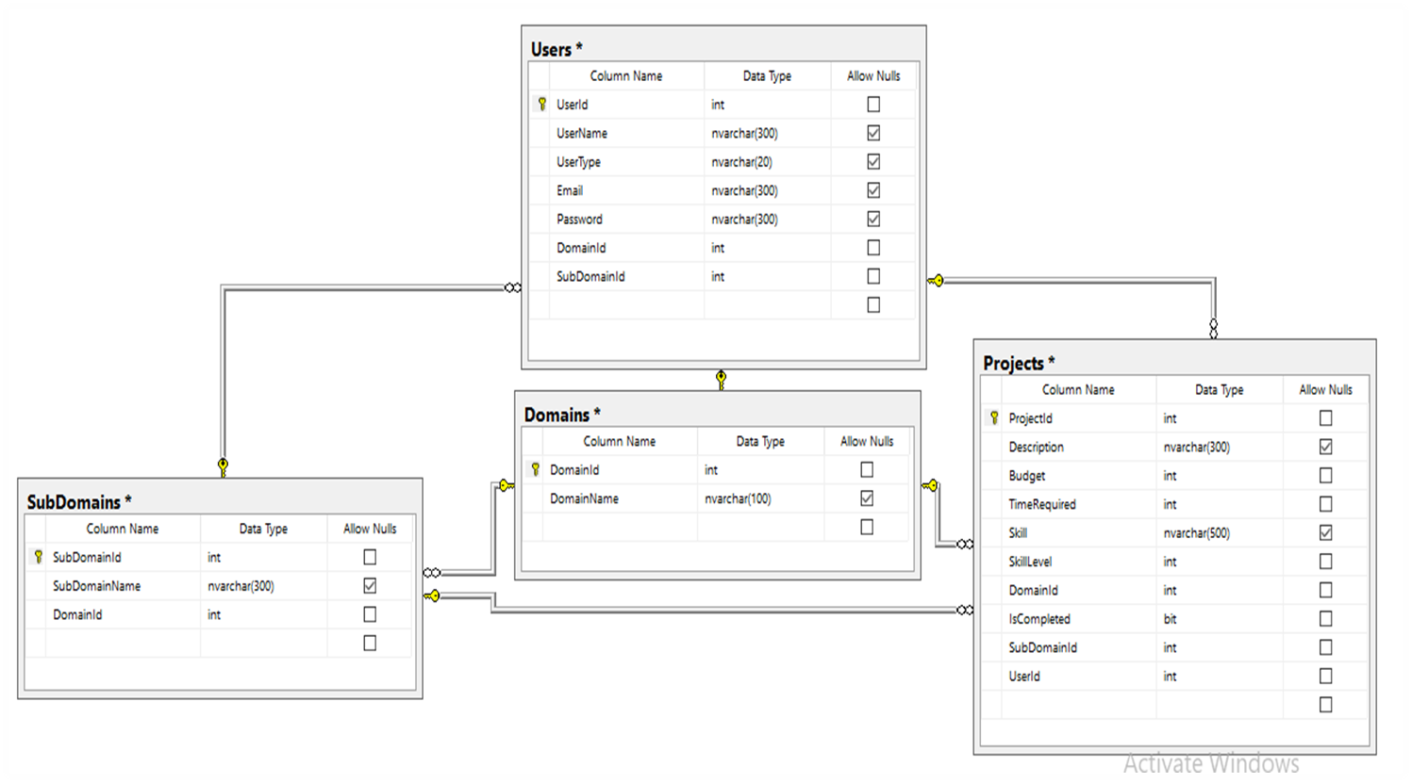

# Graphical User Interfaces

## Menu bar



## Home Screen





## SignUp

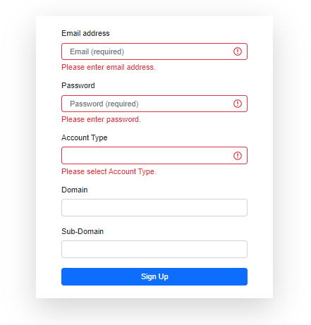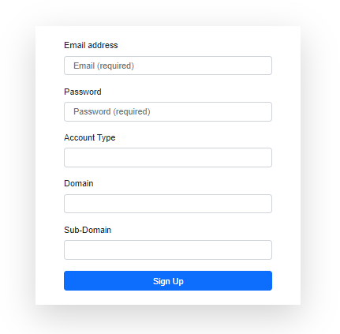

## SignIn

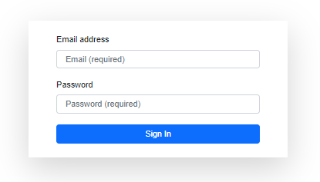

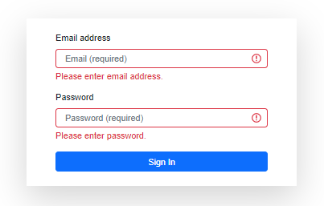

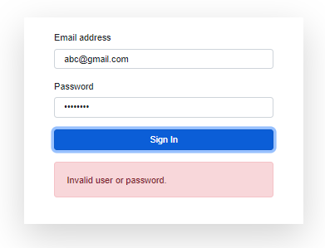

## Post Job / Display Project

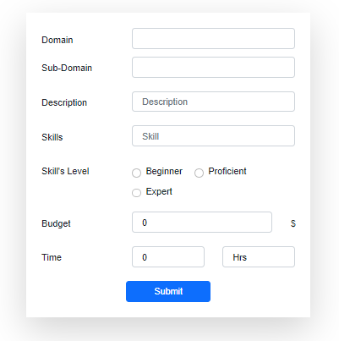

## Find Project / Find Job

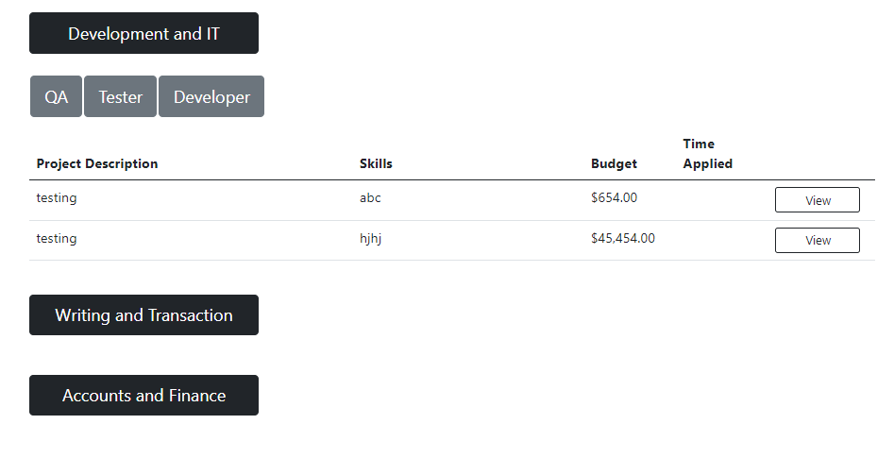

CHAPTER 3

Development

# Architecture Diagram



------------------------------------